
SpaceWire
IP Core
Specification

Mail to Authors:
btltz
btltz@opencores.org
More…

Rev. 0.1
July 28, 2026
This page has been intentionally left blank.
Revision History
Rev. | Date | Author | Description
0.1 | 28/03/05 | btltz | First Draft

Contents
Introduction 2
Architecture 2
Operation 2
Registers 2
List of Registers 2
Register 1 – Description 2
Clocks 2
IO Ports 2
Appendix A 2
Appendix B 2
Index 2

Introduction
- SpaceWire Introduction
“In short, SpaceWire is a communications Network for use onboard spacecraft.”
Composed of:
1) nodes as source or destination of packets
2) packet-switching routers, which reduce substantially the number of point-to-point links provide alternative (or redundant) paths
3) point-to-point serial links
It is designed to connect sensors, large solid-state memories, processing units and the downlink telemetry subsystem
Standard:
"ECSS-E-50-12A SpaceWire - Links, nodes, routers and networks" by ESTEC, ESA(European Space Agency).
???? for distributed processing
systems with sequential data passing from one processor to the next. ????
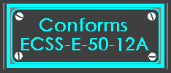

2.This IP core
The SpaceWire(SpW) IP core consists of several modules:
√ The CODEC(coder/decoder) module, which can be integrated into node or Router. It’s formed by transmitter, receiver, and FSM (also called the “PPU”, protocol process unit) for protocol control
√ The SpaceWire Interface which formed by some channels(one “channel” is a CODEC with glue logic such as FIFO or CRC) and WISHBONE compatible COMI or HOCI interface
√ The SpaceWire Router(SWR), consists of SpaceWire Interface and a dynamic switch core
And may also has:
√ Interface to other bus such as PMC, Mil-Std-1553b
√ Interface to other network such as Ethernet

Architecture
- CODEC
The CODEC(Coder-Decoder) is composed by transmitter, receiver, and PPU(protocol process unit).
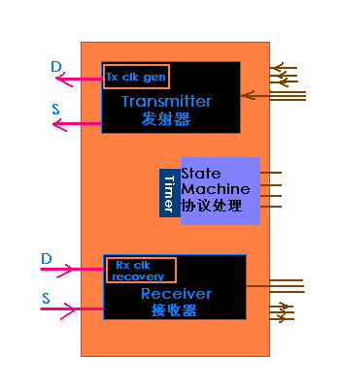

The area of the CODEC is about 10,000 gates.

- SpaceWire Interface
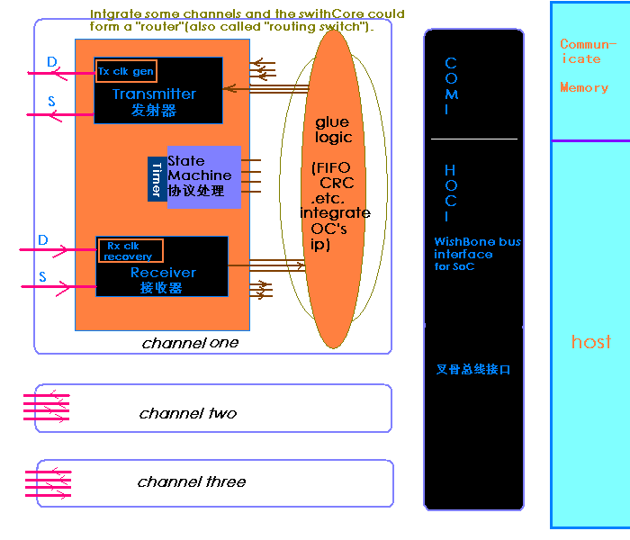
- SpaceWire Router
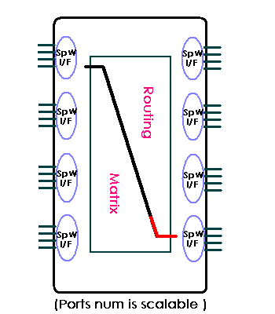

Operation
This section describes the operation of the core. Specific sequences, such as startup sequences, as well as the modes and states of the block should be described.

Registers
This section specifies all internal registers. It should completely cover the interface between the core and the host as seen from the software view.

List of Registers
Name | Address | Width | Access | Description
Table 1: List of registers

Register 1 – Description
(You shall choose the style of register you prefer. Do not use both options in one and the same document.)
Bit # | Access | Description
Reset Value:
Reg_Name: 0000h

31 | 30 | 29 | 28 | ... | 8 | 7 | 6 | 5 | 4 | 3 | 2 | 1 | 0
Table 2: Description of registers
Reset Value:
Reg_Name: 0000h

Clocks

There is 2 kind of clock: the local global clock for local operation and a clock generated by Di and Si, from the receiver clock recovery unit.

Name | Source | Rates (MHz) |  |  | Remarks | Description
Name | Source | Max | Min | Resolution | Remarks | Description
clk_pad_i | Input Pad | 10 | 4 | 0.1 | Duty cycle 70/30. | For external interface.
wb_clk_I | PLL | 200 | - | - | Must be synchronized to sm_clk_i | System clock.
sm_clk_i | Input port | 55 | 40 | 1 | There are multi-clocks paths. | Clock 55MHz for State machine.
Table 3: List of clocks

IO Ports
WISHBONE DATASHEET:

Port | Width | Direction | Description
wb_clk_i | 1 | Input | Block’s WISHBONE Clock Input
wb_rst_i | 1 | Input | Block’s WISHBONE Reset Input
wb_sel_i | 4 | Input | Block’s WISHBONE Select Inputs
foo_pad_o | 1 | Output | Block’s foo output to output pad
…
Table 4: List of IO ports

Table A-1. WISHBONE DATASHEET for the 8-bit output port example.
Port | Width | Direction | Description
wb_clk_i | 1 | Input | Block’s WISHBONE Clock Input
wb_rst_i | 1 | Input | Block’s WISHBONE Reset Input
wb_sel_i | 4 | Input | Block’s WISHBONE Select Inputs
foo_pad_o | 1 | Output | Block’s foo output to output pad
…

General description: 8-bit SLAVE output port.
Supported cycles:
SLAVE, READ/WRITE
SLAVE, BLOCK READ/WRITE
SLAVE, RMW
Data port, size:
Data port, granularity:
Data port, maximum operand size:
Data transfer ordering:
Data transfer sequencing:
8-bit
8-bit
8-bit
Big endian and/or little endian
Undefined
Supported signal list and cross reference
to equivalent WISHBONE signals:
Signal Name WISHBONE Equiv.
ACK_O ACK_O
CLK_I CLK_I
DAT_I(7..0) DAT_I()
DAT_O(7..0) DAT_O()
RST_I RST_I
STB_I STB_I
WE_I WE_I

Table A-4. WISHBONE DATASHEET for the 16 x 8-bit SLAVE memory.
Description Specification
General description: 16 x 8-bit memory IP core.
Supported cycles:
SLAVE, READ/WRITE
SLAVE, BLOCK READ/WRITE
SLAVE, RMW
Data port, size:
Data port, granularity:
Data port, maximum operand size:
Data transfer ordering:
Data transfer sequencing:
8-bit
8-bit
8-bit
Big endian and/or little endian
Undefined
Clock frequency constraints: NONE (determined by memory primitive)
Supported signal list and cross reference
to equivalent WISHBONE signals:
Signal Name WISHBONE Equiv.
ACK_O ACK_O
ADR_I(3..0) ADR_I()
CLK_I CLK_I
DAT_I(7..0) DAT_I()
DAT_O(7..0) DAT_O()
STB_I STB_I
WE_I WE_I
Special requirements:
Circuit assumes the use of synchronous
RAM primitives with asynchronous read
capability.

Reference

Another design document “SpaceWire IP Core design document” has more details for design the IP itself.

Industry info and some Web site could be accessed for further reference:
1. "SpaceWire UK are specialist providers of VHDL Intellectual Property & Design Services for the Space Industry".
The SpaceWire UK has developed a CODEC and SpaceWire Switch Core (Router) in VHDL for business. (I am sure i don't want to disturb this new ip vendor and I also had consulted their ip schemes. My try is just a hobby and have a heart to contribute to promoting the SpW standard.)
http://www.spacewire.co.uk/

2) The EADS Astrium GmbH (formed in May 2000 by the merger of Matra Marconi Space (France/UK) and the space division of DaimlerChrysler Aerospace (Germany)) is well known as the author of the "Router requirements spec" (Steve Parkes, University of Dundee).
" ETD-031 'SpaceWire Router Development, Coordination and Validation' was Kicked-Off with Astrium the 2nd January 2002. " And the issue 1 rev 5 had been published on 28.02.2003.
They described a router ASIC with internal configuration port,external pins for status/error monitoring (with status/error registers and control registers) in Feb,2004.It had been implemented in an Atmel MH1RT gate array.
http://www.astrium.eads.net/

3) Austrian Aerospace (AAE) has a switch ASIC, the Dynamic Switch Matrix (DSM), built in Atmel. " ESM-006 'SpaceWire Router ASIC development' is an ETD-031 sub-contract with Austrian Aerospace concerning the SpaceWire CODEC VHDL, router FPGA and router ASIC. "
http://www.space.at/

4) 4links derives from University of Dundee is a company that specializes in SpaceWire / IEEE1355 &Ethernet.
They have some products such as EtherSpaceLink, SpaceWire-cPCI, SpaceWire-PCI, SpaceWire-Cables, and IPs which are relative to these products. They use Xilinx fpga implement routers with a performance well above 200 Mbit/s.
http://www.4links.co.uk/index.htm

5) Webs of Chinese laboratory of avionics (for space use) say they are developing a SpW network system..(Language = Simple Chinese)
http://www.spacee.net/

6) Atmel offer SMCS332,SMCS Lite, and said their "potential future Standard ASICs & IPs include:SMCS Lite, SpaceWire Router(2004),SpaceWire Rx/Tx" in 2002.
http://www.atmel.com/

7) STAR-Dundee Ltd is a spin-out company of the University of Dundee set up specifically to support users of SpaceWire(fund from the Scottish Executive). Dr Steve Parkes was the Managing Director of STAR-Dundee, also the author of the SpaceWire standard document. "STAR-Dundee Ltd aims to fill the emerging market niche for research and development, debug and support tools for SpaceWire."
Dr Steve Parkes: sparkes@computing.dundee.ac.uk
Press Officer: j.m.marra@dundee.ac.uk
http://www.dundee.ac.uk/

8) :--) Ask Google for more and fresh news.

